Class 3
Term 6 Week Five! 29.6.2020

SPORTS WEEK

BIG QUESTION 17
Can you find out some of the history of Martial arts.
Sticking a little with our theme, can you find out about the origins of one of the many martial arts that originated in ancient Asia.

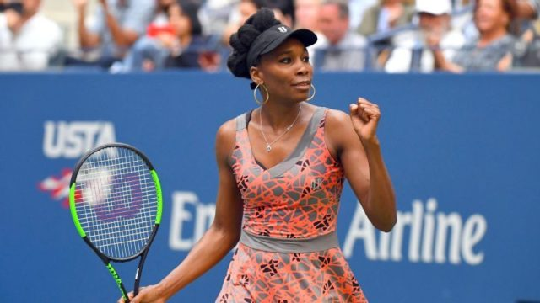

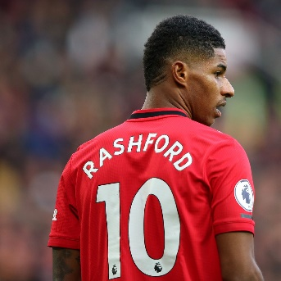
BIG QUESTION 18
Tell me all about a sports person that shows our values.
Can you think of a sports personality that you know what makes them inspiring? How have they showed our values?
Tell me all about them?
If you’re stuck from some inspiration maybe look at the nominees for BBC sports personality of the year, or check out the pictured people I find inspiring (Venus Williams and Marcus Rashford)

BIG QUESTION 19
What might the future hold for sports - can you invent a new sport?
What might it look like? How do you compete? What are the rules?
What does the winning trophy/medal look like?
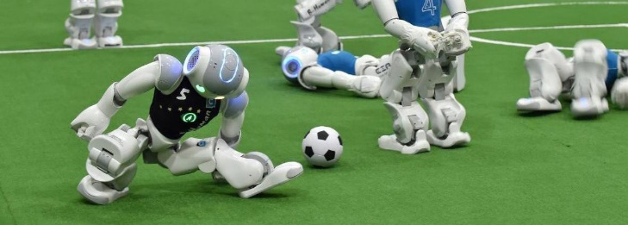
What special equipment/kit do you need?

