Class 3
Term 6 Week Six! 6.7.2020

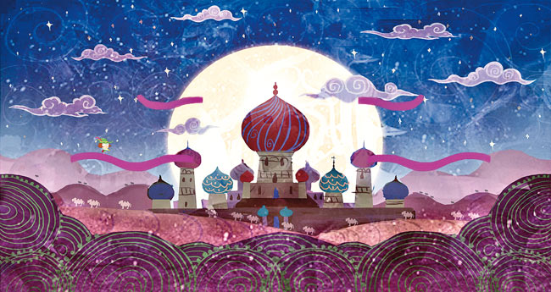
BIG QUESTION 20
1002 Arabian nights
Have a look at the story
http://www.imaginative-inquiry.co.uk/wp-content/uploads/2014/02/Baghdad-film.mp4 - Film of Scheherazade;

Can you use this story to…
- Plot the story mountain
- Create some character profiles
- Collect some adjectives, Proper nouns, adverbials
- Write to the king to persuade him to give his permission for them to visit Scheherazade once they have found more stories.

BIG QUESTION 21
How have you done?
Take a moment to reflect, what have you learnt this theme? What are your projects that you’re really proud of?
Can you record these to share with me.
You could… make a power point, a poster, or a mind map.
Here are some quizzes on our topic you could challenge yourself with.
https://www.ducksters.com/history/china/ancient_china_questions.php
https://www.ducksters.com/history/islam/islam_questions.php

