Daily Challenge Wk 7
Numeracy
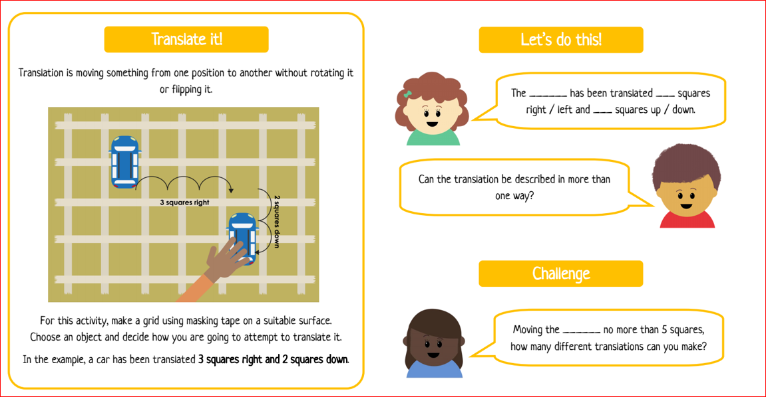
Literacy
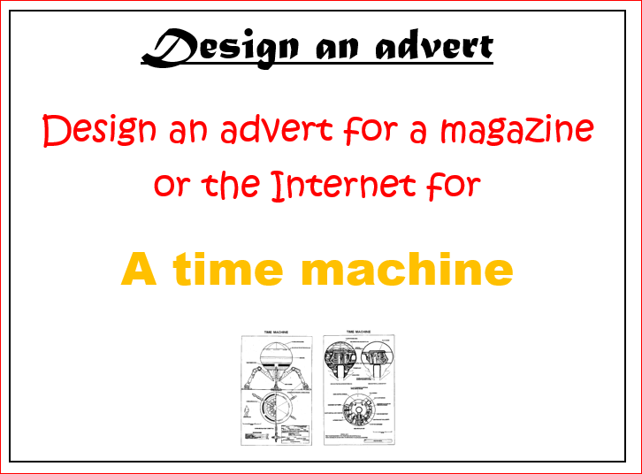
The Photographer Challenge
We want to see your talents with a camera. We would like you to try your hand at ‘Flat Lay’ photography.
What’s ‘Flat Lay’? It’s a certain type of photo that’s taken directly above, like a bird’s eye view. Like this…
Things to think about:
- What will your background be? Are you putting the art on a plate, paper, grass outside?
- What will you photograph? Will you have a theme like nature, food, colours?
- Make sure your camera is directly over the art.
- What will you call your piece?
Enjoy making your creation and don’t forget to send us a snap!
Well-being Task
Visit a virtual museum. Explore the museum and see the different artefacts they have.

