**Daily Challenge Wk 1**

Numeracy

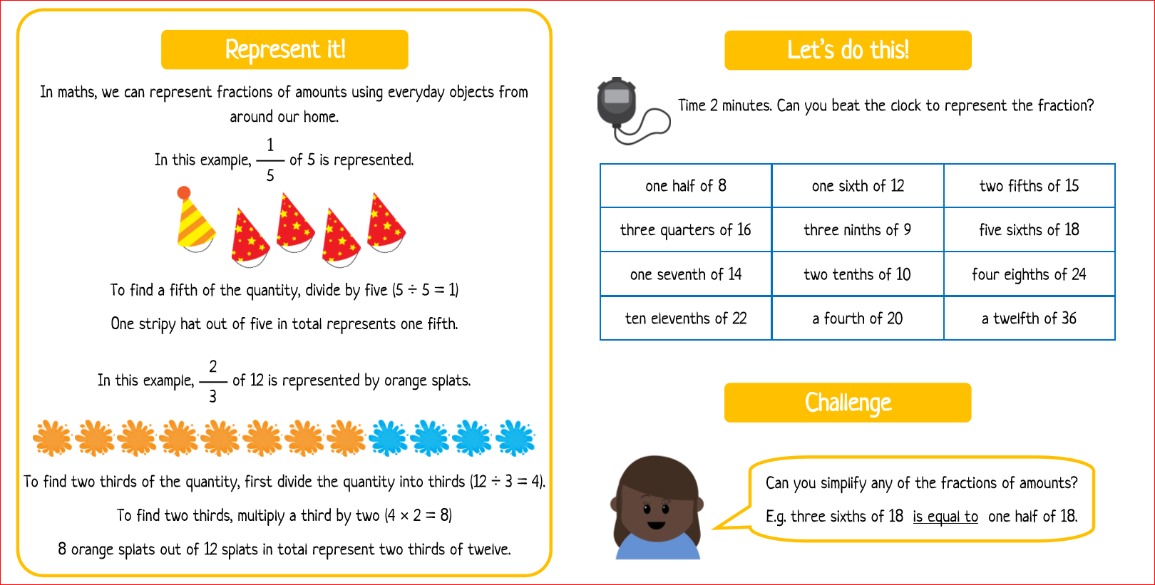

Literacy

**The Night Thieves**

Finish the story!

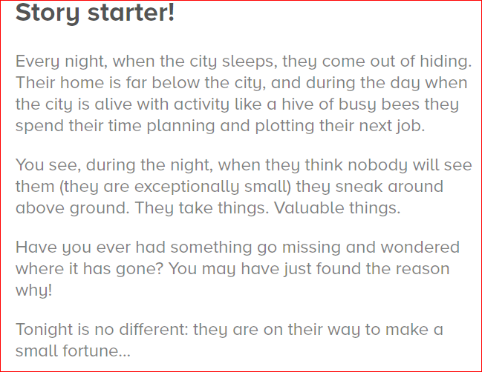 

STEM Challenge

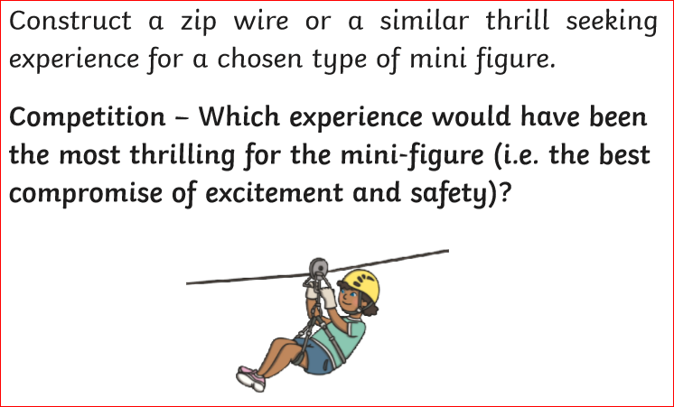

Well-being Task

*Plan a family meal you would like to cook for your family.*

*Write down the recipe and think about how you could make it really special.*