**Daily Challenge Wk 6**

Numeracy

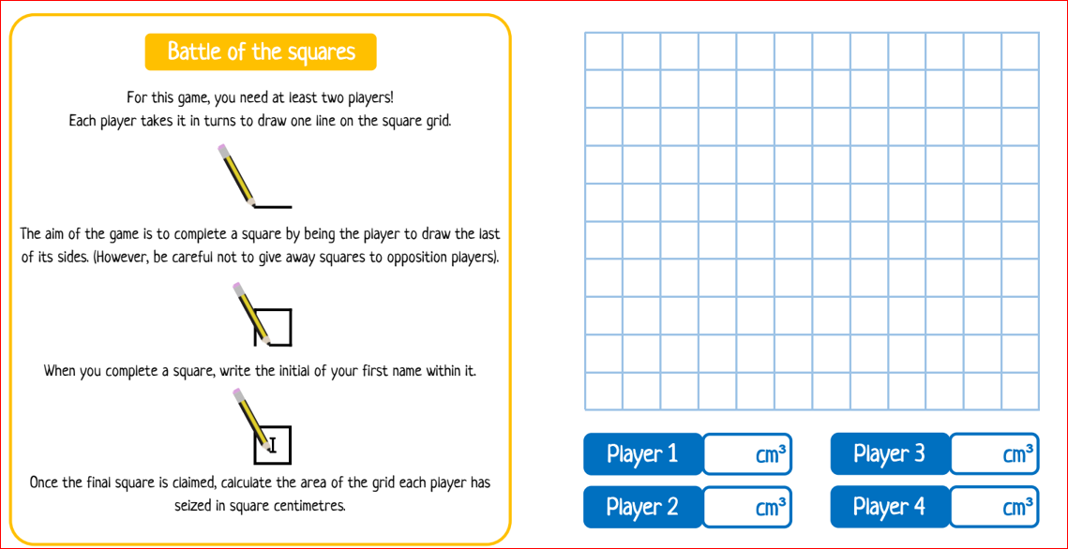

Literacy

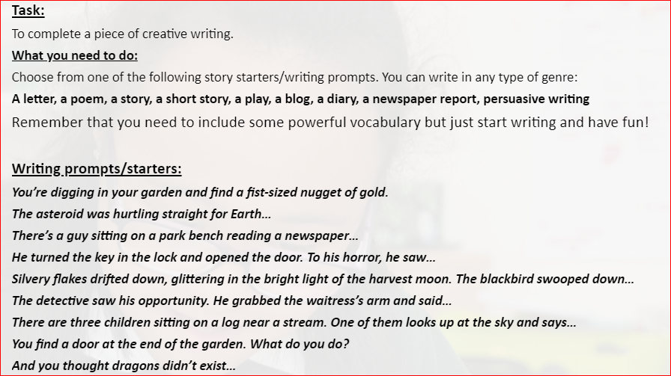

STEM Challenge

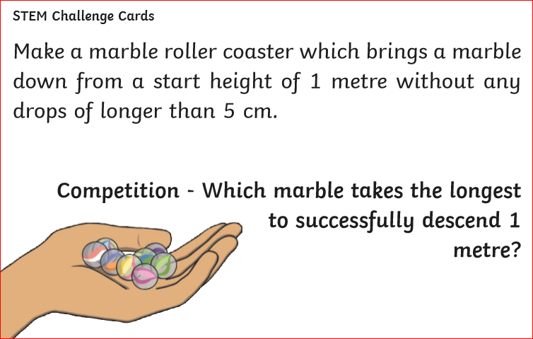

Well-being Task

*Draw a detailed picture of what you can see out of your window.*