**Daily Challenge Wk 5**

Numeracy

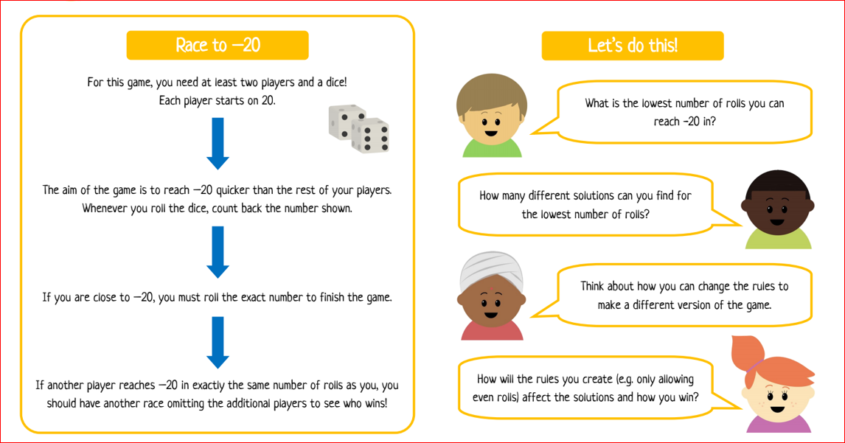

Literacy

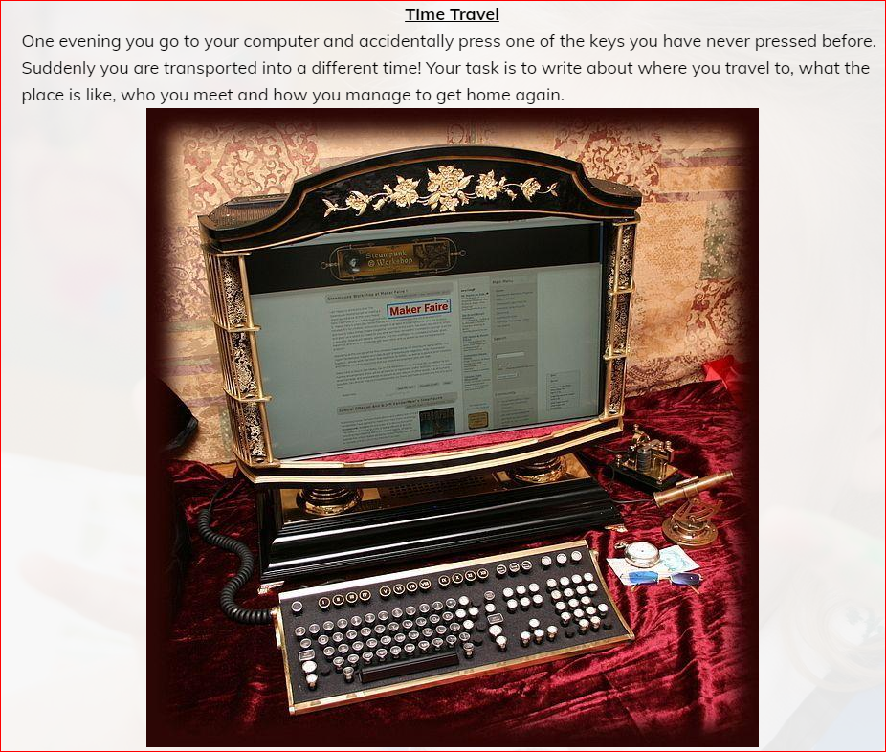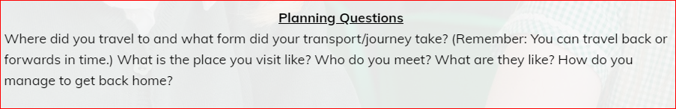

STEM Challenge

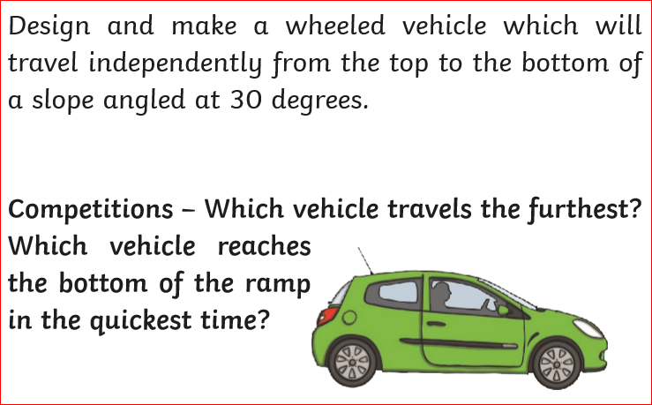

**Well-being Task**

*Think about two role models in your life.*

*Who are they are why do they inspire you?*

*Make a poster about them.*