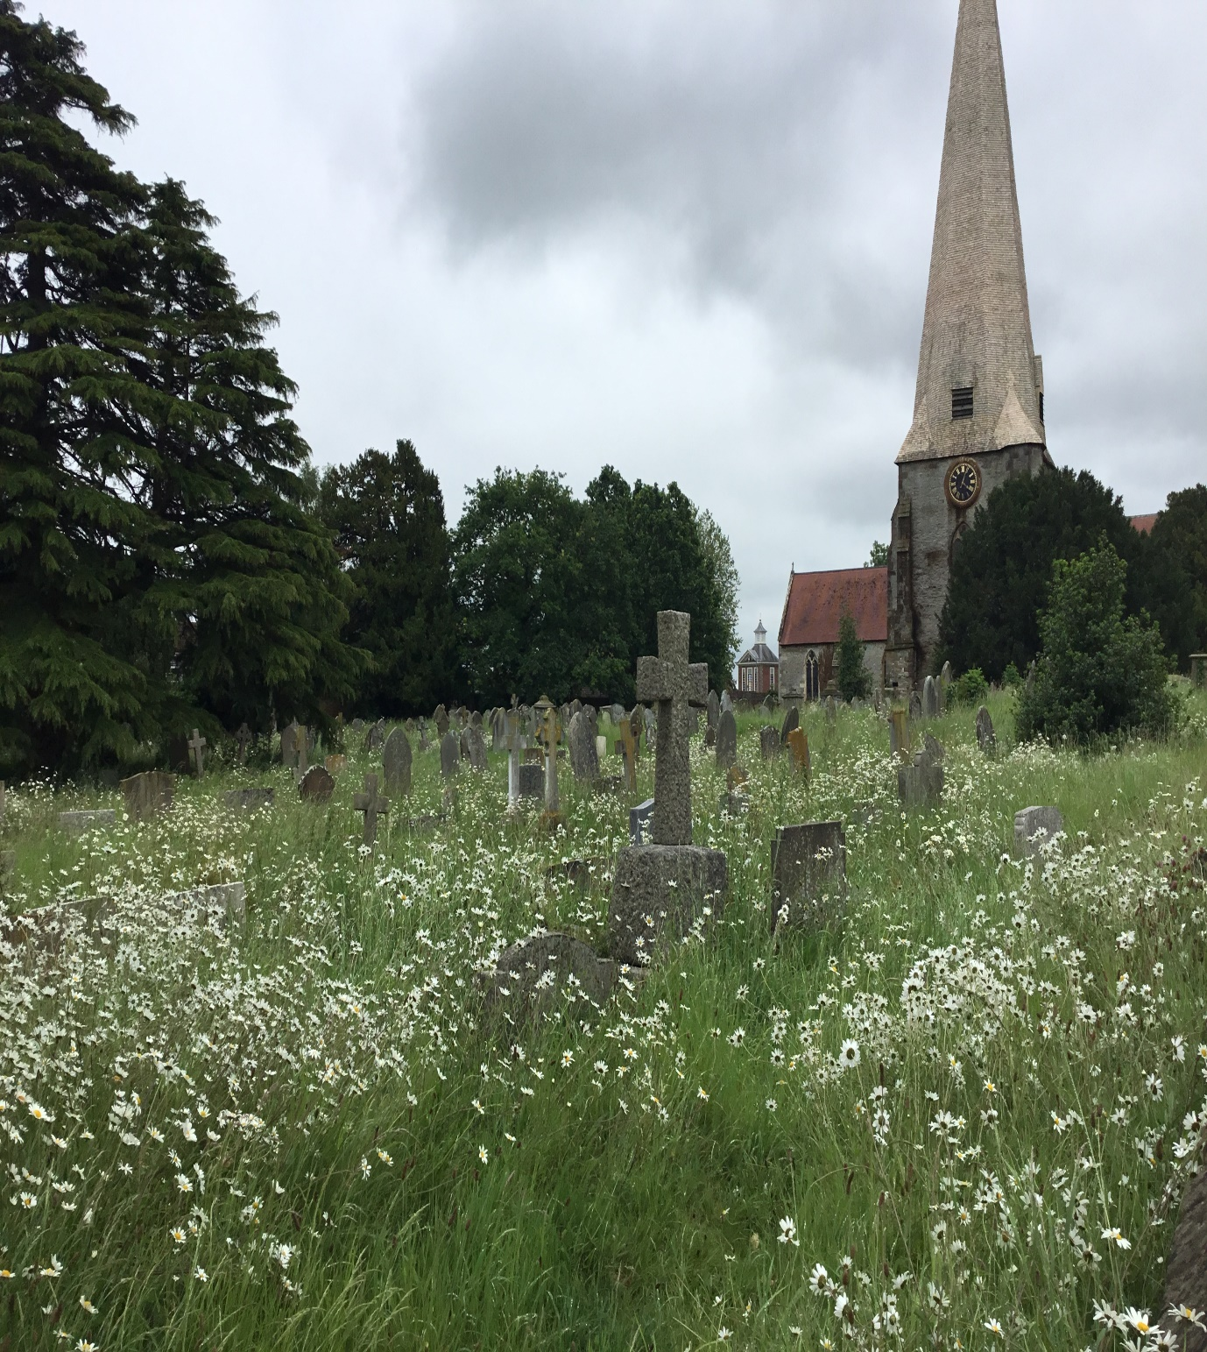
Westbury Church
invites you and your families to a
FAMILY SERVICE
at 10am
Led by Mr David Crunkhurn and members of the Worship Team of Westbury School
on
SUNDAY 12th December
Please bring all the family, old and young, & support our new, all age worship initiative.
Refreshments afterwards
This is also an opportunity to say goodbye and thank you to Mr C from our community as he leaves Westbury School at the end of this term after 13 years.

