Friends of Westbury School are providing a tree to display in the Christmas Tree Festival and would like all the children to create a decoration to hang on the tree.
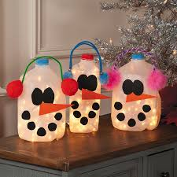
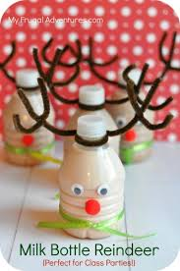
Your child will be bringing home an empty milk bottle to decorate and turn into a unique Christmas decoration. All decorated bottles must be in school by Thursday 5th December.

