Class 3
Term 6 Week Four! 22.6.2020

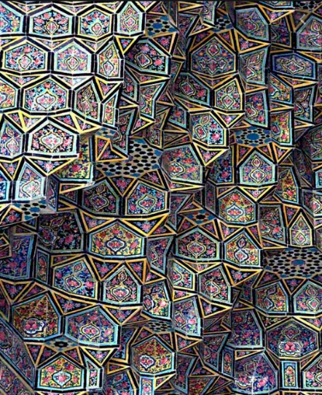
BIG QUESTION 15
What are some of the Islamic art, patterns and motifs?
Have a look at some examples of early Islamic art and patterns.
How are these made?
What do you notice about them, are there any rules?
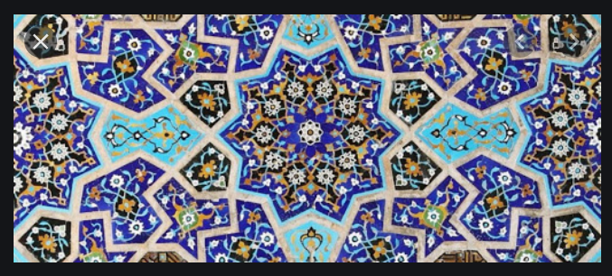
Can you recreate your own?

Can you design a decoration for a room, (rug, cushion) using your own pattern?

BIG QUESTION 16
This week would have been transition week in school. I’d like you to spend some time thinking about next year and our new class.

Can you think of some goals for next year?
What do you want to achieve?
What will you be working hard on?

What are you looking forward to next year?
What things are you excited about?
What would you like the class to be like? (rules, important things to remember)

